**Biola Invitational 5,000m Course Map**

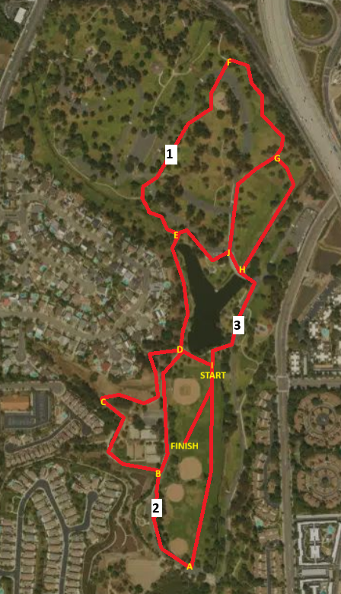

**START-A-B-C-D-E-1MI-F-G-H-I-A-2MI-B-C-D-E-J-G-H-3MI-I-FINISH**

**Biola Invitational 8,000m Course Map**

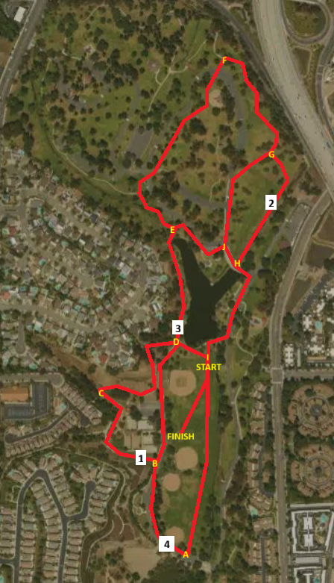

**START-A-B-D-I-A-B-1MI-C-D-E-F-G-2MI-H-I- A-B-C-D-3MI-E-J-G-H-I-A-4MI-B-C-D-E-J-H-I-FINISH**